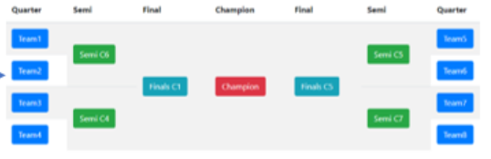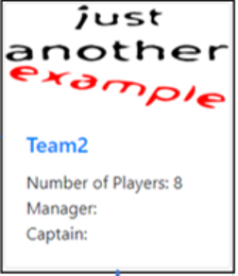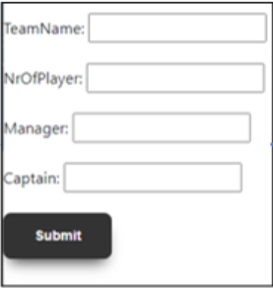

Page: Tournamenttree

Create/depic Tournamenttree

🡪bottom of tournament tree list all games for tournament 🡪 winner moves 1 step further e.g. semifinal

Page: Teamlist

e.g. 8 Teams

🡪 8 blank Teamforms for input Team

After input 8 Teams 🡪 submit 🡪 bootstraps cards

Home page

Input Tournament name

Input/Choose Tournament size

Submit